Analysis Results: Profitability, Risk, Volume & Sentiment

1)Merged data:

Account Coin Execution Price \

0 0x3998f134d6aaa2b6a5f723806d00fd2bbbbce891 ETH 1897.9

1 0xb1231a4a2dd02f2276fa3c5e2a2f3436e6bfed23 BTC 41867.0

2 0xb1231a4a2dd02f2276fa3c5e2a2f3436e6bfed23 ETH 2230.1

3 0xb1231a4a2dd02f2276fa3c5e2a2f3436e6bfed23 ETH 2252.3

4 0xb1231a4a2dd02f2276fa3c5e2a2f3436e6bfed23 BTC 42748.0

Size Tokens Size USD Side Timestamp IST Start Position \

0 0.0967 183.53 BUY 2023-05-01 01:06:00 0.00000

1 0.0150 628.00 SELL 2023-12-05 03:11:00 0.00000

2 0.4933 1100.11 BUY 2023-12-05 03:11:00 0.00000

3 11.2119 25252.56 SELL 2023-12-14 01:20:00 11.21190

4 0.0150 641.22 BUY 2023-12-14 01:20:00 -0.59711

Direction Closed PnL Transaction Hash \

0 Open Long 0.000000 0x875d3e1af52b5b758e4f04015b774e0111006a118601...

1 Open Short 0.000000 0xd2e598f2a6ca3f77dc7b04065f9e8a0139006b7925f4...

2 Open Long 0.000000 0x02721e3c6061bddfdc1204065f9dfe0138003649ef8c...

3 Close Long 245.428491 0xbde1c54544084c04304604068cff13011400d81cb2b8...

4 Close Short -13.230000 0xaa5402f2a57de3b0357b04068cff0e0112004938d7f4...

Order ID Crossed Fee Trade ID Timestamp \

0 173271100 True 0.000000 0.000000e+00 1.680000e+12

1 4064974623 True 0.157001 1.070000e+15 1.700000e+12

2 4064960965 True 0.275027 6.320000e+14 1.700000e+12

3 4626057386 True 6.313140 6.790000e+14 1.700000e+12

4 4626056690 True 0.160305 8.320000e+14 1.700000e+12

timestamp value classification date

0 1970-01-01 00:00:01.746163800 67 Greed 2025-05-02

1 1970-01-01 00:00:01.746163800 67 Greed 2025-05-02

2 1970-01-01 00:00:01.746163800 67 Greed 2025-05-02

3 1970-01-01 00:00:01.746163800 67 Greed 2025-05-02

4 1970-01-01 00:00:01.746163800 67 Greed 2025-05-02

2)Summary of numerical columns

execution price size tokens size usd \

count 36468.000000 3.646800e+04 3.646800e+04

mean 10281.176727 1.137274e+04 4.883988e+03

min 0.000005 8.740000e-07 0.000000e+00

25% 1.130225 4.200000e+00 1.362000e+02

50% 14.550000 3.940000e+01 4.998000e+02

75% 49.024000 3.387450e+02 1.499980e+03

max 109004.000000 1.582244e+07 3.719141e+06

std 28471.007696 2.121044e+05 4.872111e+04

timestamp ist start position closed pnl \

count 36468 3.646800e+04 36468.000000

mean 2025-01-05 05:24:58.476472576 -6.758383e+04 54.377066

min 2023-05-01 01:06:00 -1.397130e+07 -34338.534090

25% 2024-12-11 19:18:45 -2.950000e+02 0.000000

50% 2025-01-20 07:46:00 1.454000e-02 0.000000

75% 2025-03-04 01:27:00 1.185075e+03 2.739066

max 2025-05-01 12:13:00 3.050948e+07 115287.000000

std NaN 8.356765e+05 1068.765452

order id fee trade id timestamp \

count 3.646800e+04 36468.000000 3.646800e+04 3.646800e+04

mean 6.322833e+10 0.843413 5.577840e+14 1.735638e+12

min 1.732711e+08 -1.175712 0.000000e+00 1.680000e+12

25% 5.463174e+10 0.018413 2.740000e+14 1.730000e+12

50% 6.461374e+10 0.077635 5.570000e+14 1.740000e+12

75% 7.672902e+10 0.290706 8.420000e+14 1.740000e+12

max 9.014921e+10 754.307241 1.130000e+15 1.750000e+12

std 1.873085e+10 6.899775 3.273696e+14 9.039541e+09

timestamp value date

count 36468 36468.0 36468

mean 1970-01-01 00:00:01.746163800 67.0 2025-05-02 00:00:00

min 1970-01-01 00:00:01.746163800 67.0 2025-05-02 00:00:00

25% 1970-01-01 00:00:01.746163800 67.0 2025-05-02 00:00:00

50% 1970-01-01 00:00:01.746163800 67.0 2025-05-02 00:00:00

75% 1970-01-01 00:00:01.746163800 67.0 2025-05-02 00:00:00

max 1970-01-01 00:00:01.746163800 67.0 2025-05-02 00:00:00

std NaN 0.0 NaN

3)Visualizing numerical columns

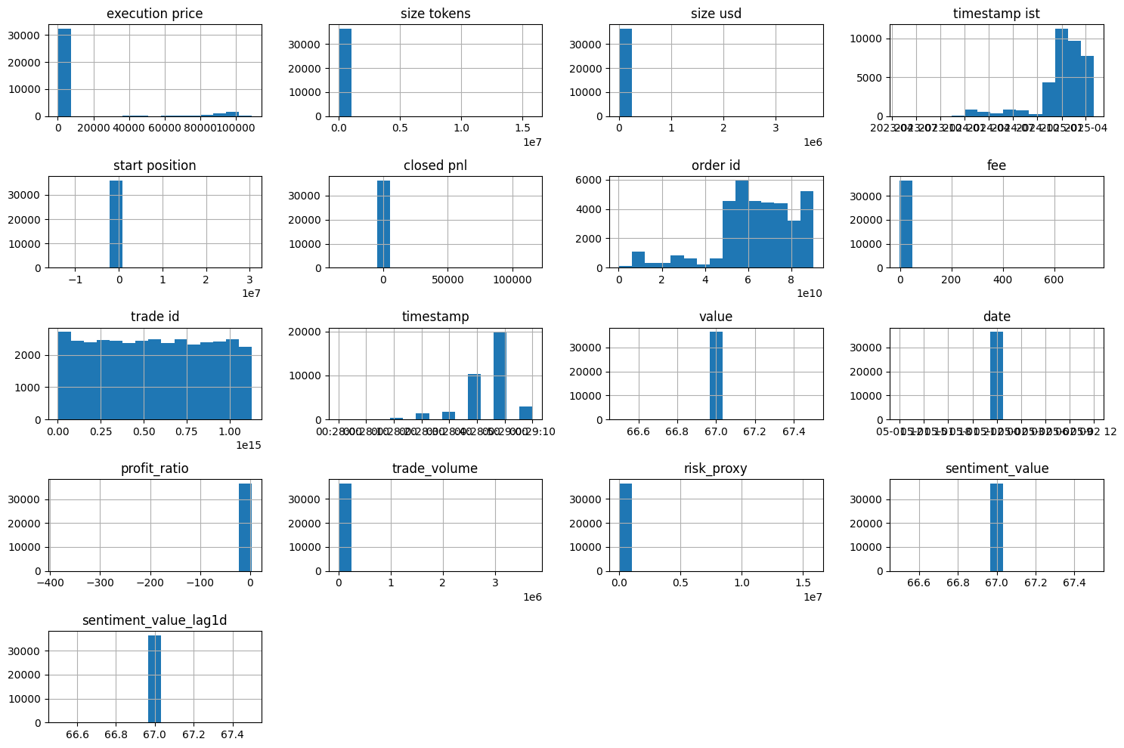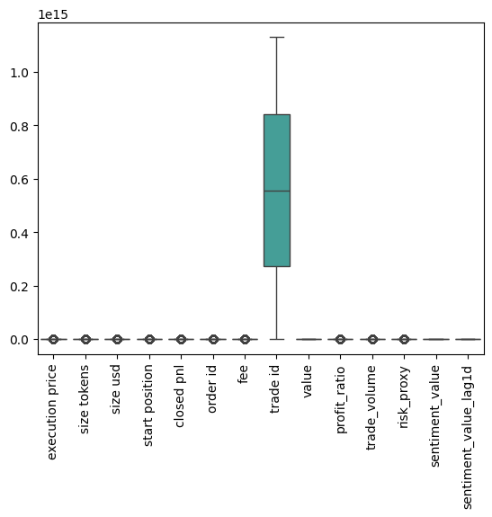

4)Profitability Ratio vs Market Sentiment  
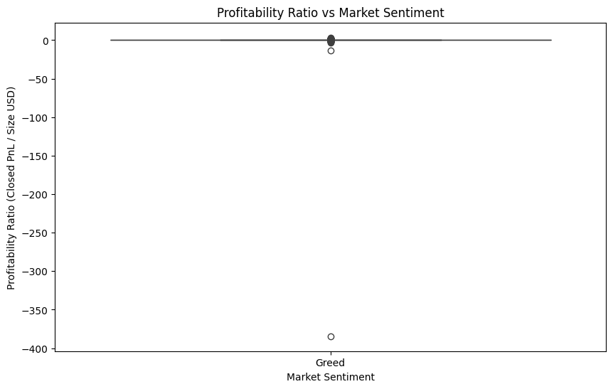  
5)Trade volume vs Market sentiment

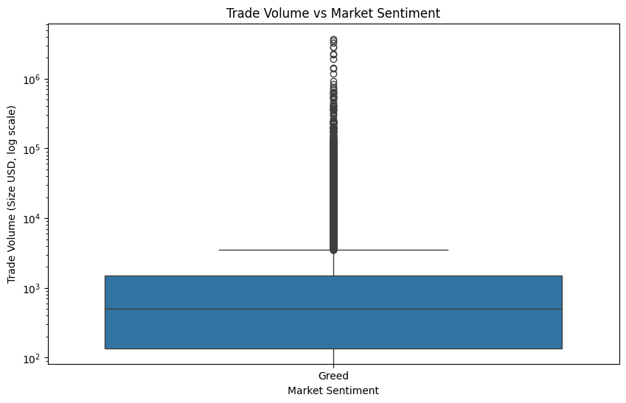  
6)Risk Proxy vs Market Sentiment

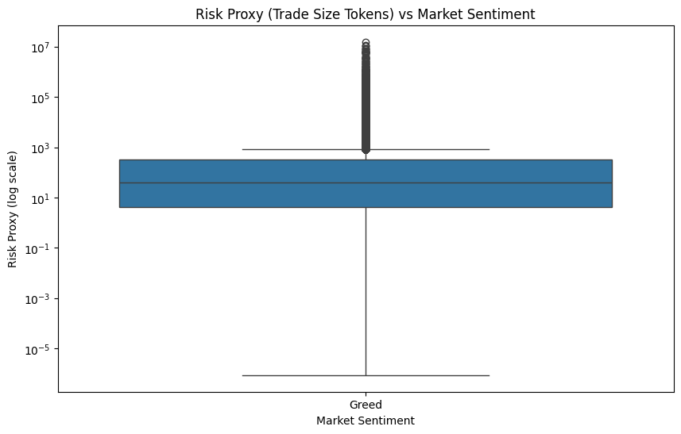

7)Correlation

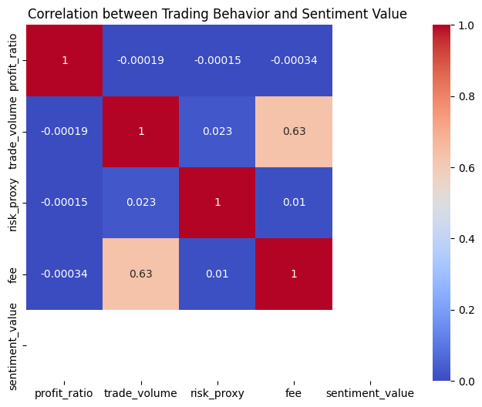

8)Lagged sentiment vs Profitabilty Ratio

